

Kingdom of Saudi Arabia

Ministry of Education

Om Al Moamnean Elementary School

The 4th period Exam for the 6th Grade

Student's Name:

…………………………………………………

|  |  |  |  |  |  |
| --- | --- | --- | --- | --- | --- |
| 80% | 90%-80% | 100%-90% | 100% | Ask questions using What, Who, where, why, | المعيار 11 |
|  |  |  |  |

1- Choose the correct answers :

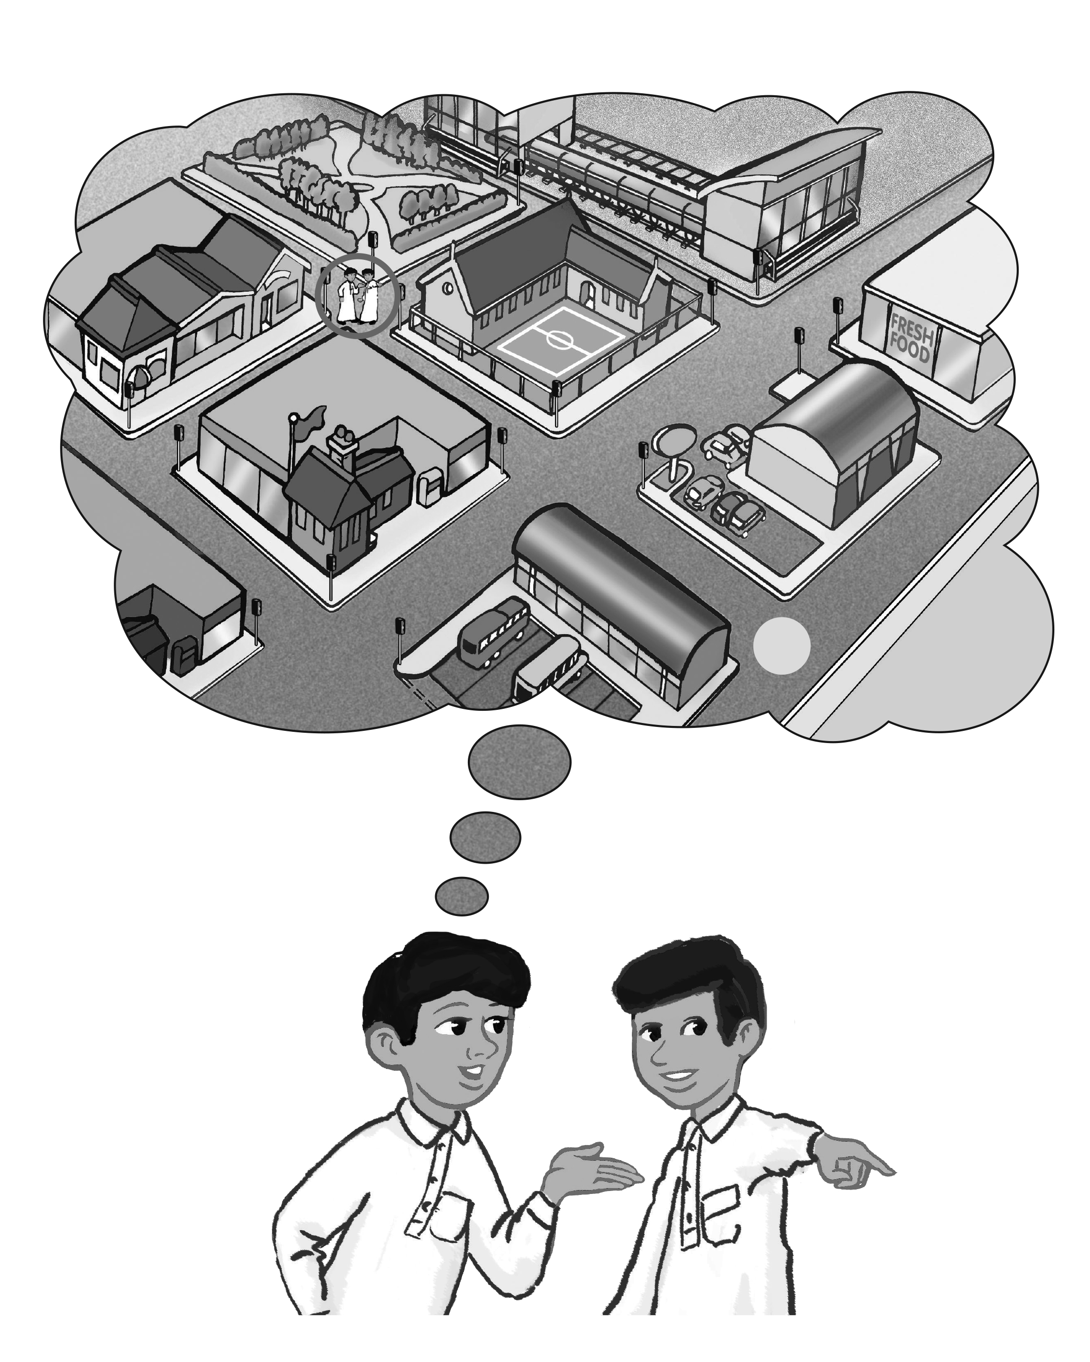

1- Where's the bus stop ?

a- It's about 5 minutes walk.

b- Your welcome .

2- It's only a few minute .

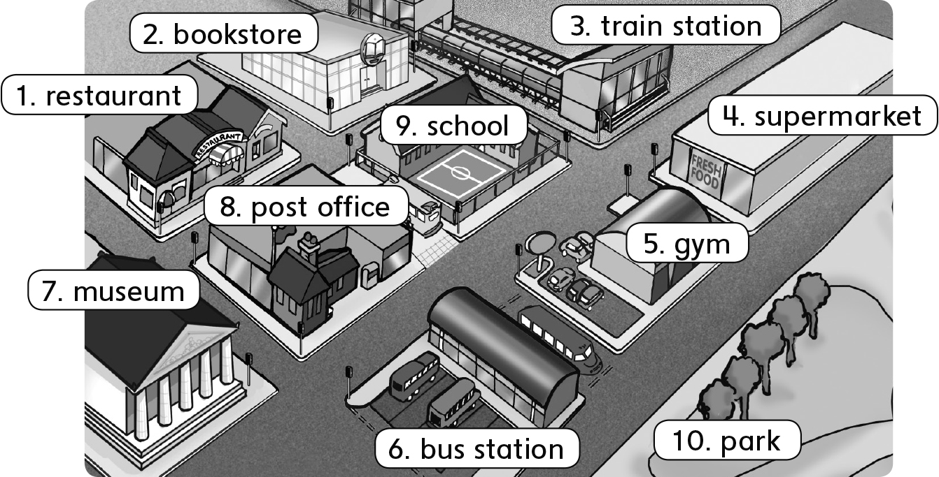

a- How long does it take to go to supermarket ?

b- Is it far from here ?

3- supermarket - ? - Where - is

…………………………………………………………………………………………

4- far - from - It's - . - here

………………………………………………………………………………………

|  |  |  |  |  |  |
| --- | --- | --- | --- | --- | --- |
| 80% | 90%-80% | 100%-90% | 100% | alk about activities in the moment of speaking using Present Progressive ( + / - / ? / A) | المعيار 17 |
|  |  |  |  |

2- Match the following :

1- I want glue . I'm going to the stationery store.

2- kids want some candy . They're going to candy store.

3- Amal wants some bread and cake. She's going to bakery.

4- Ali wants a new DVD . He's going to DVD store.

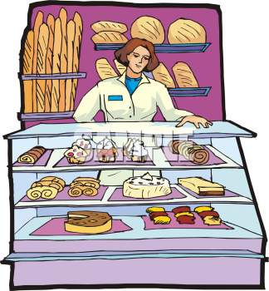



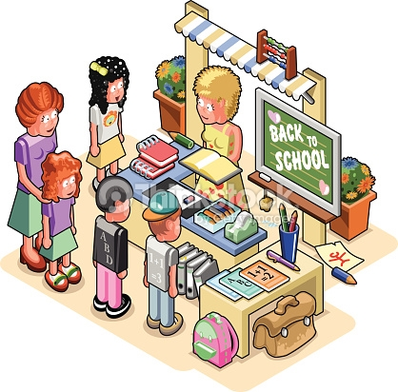



|  |  |  |  |  |  |
| --- | --- | --- | --- | --- | --- |
| 80% | 90%-80% | 100%-90% | 100% | Talk about different items in the house using There is / There are  Describe location (on, in, under, next to, between, opposite, in front of, behind) | المعيار 21 - 19 |
|  |  |  |  |

3- Match the following correctly :

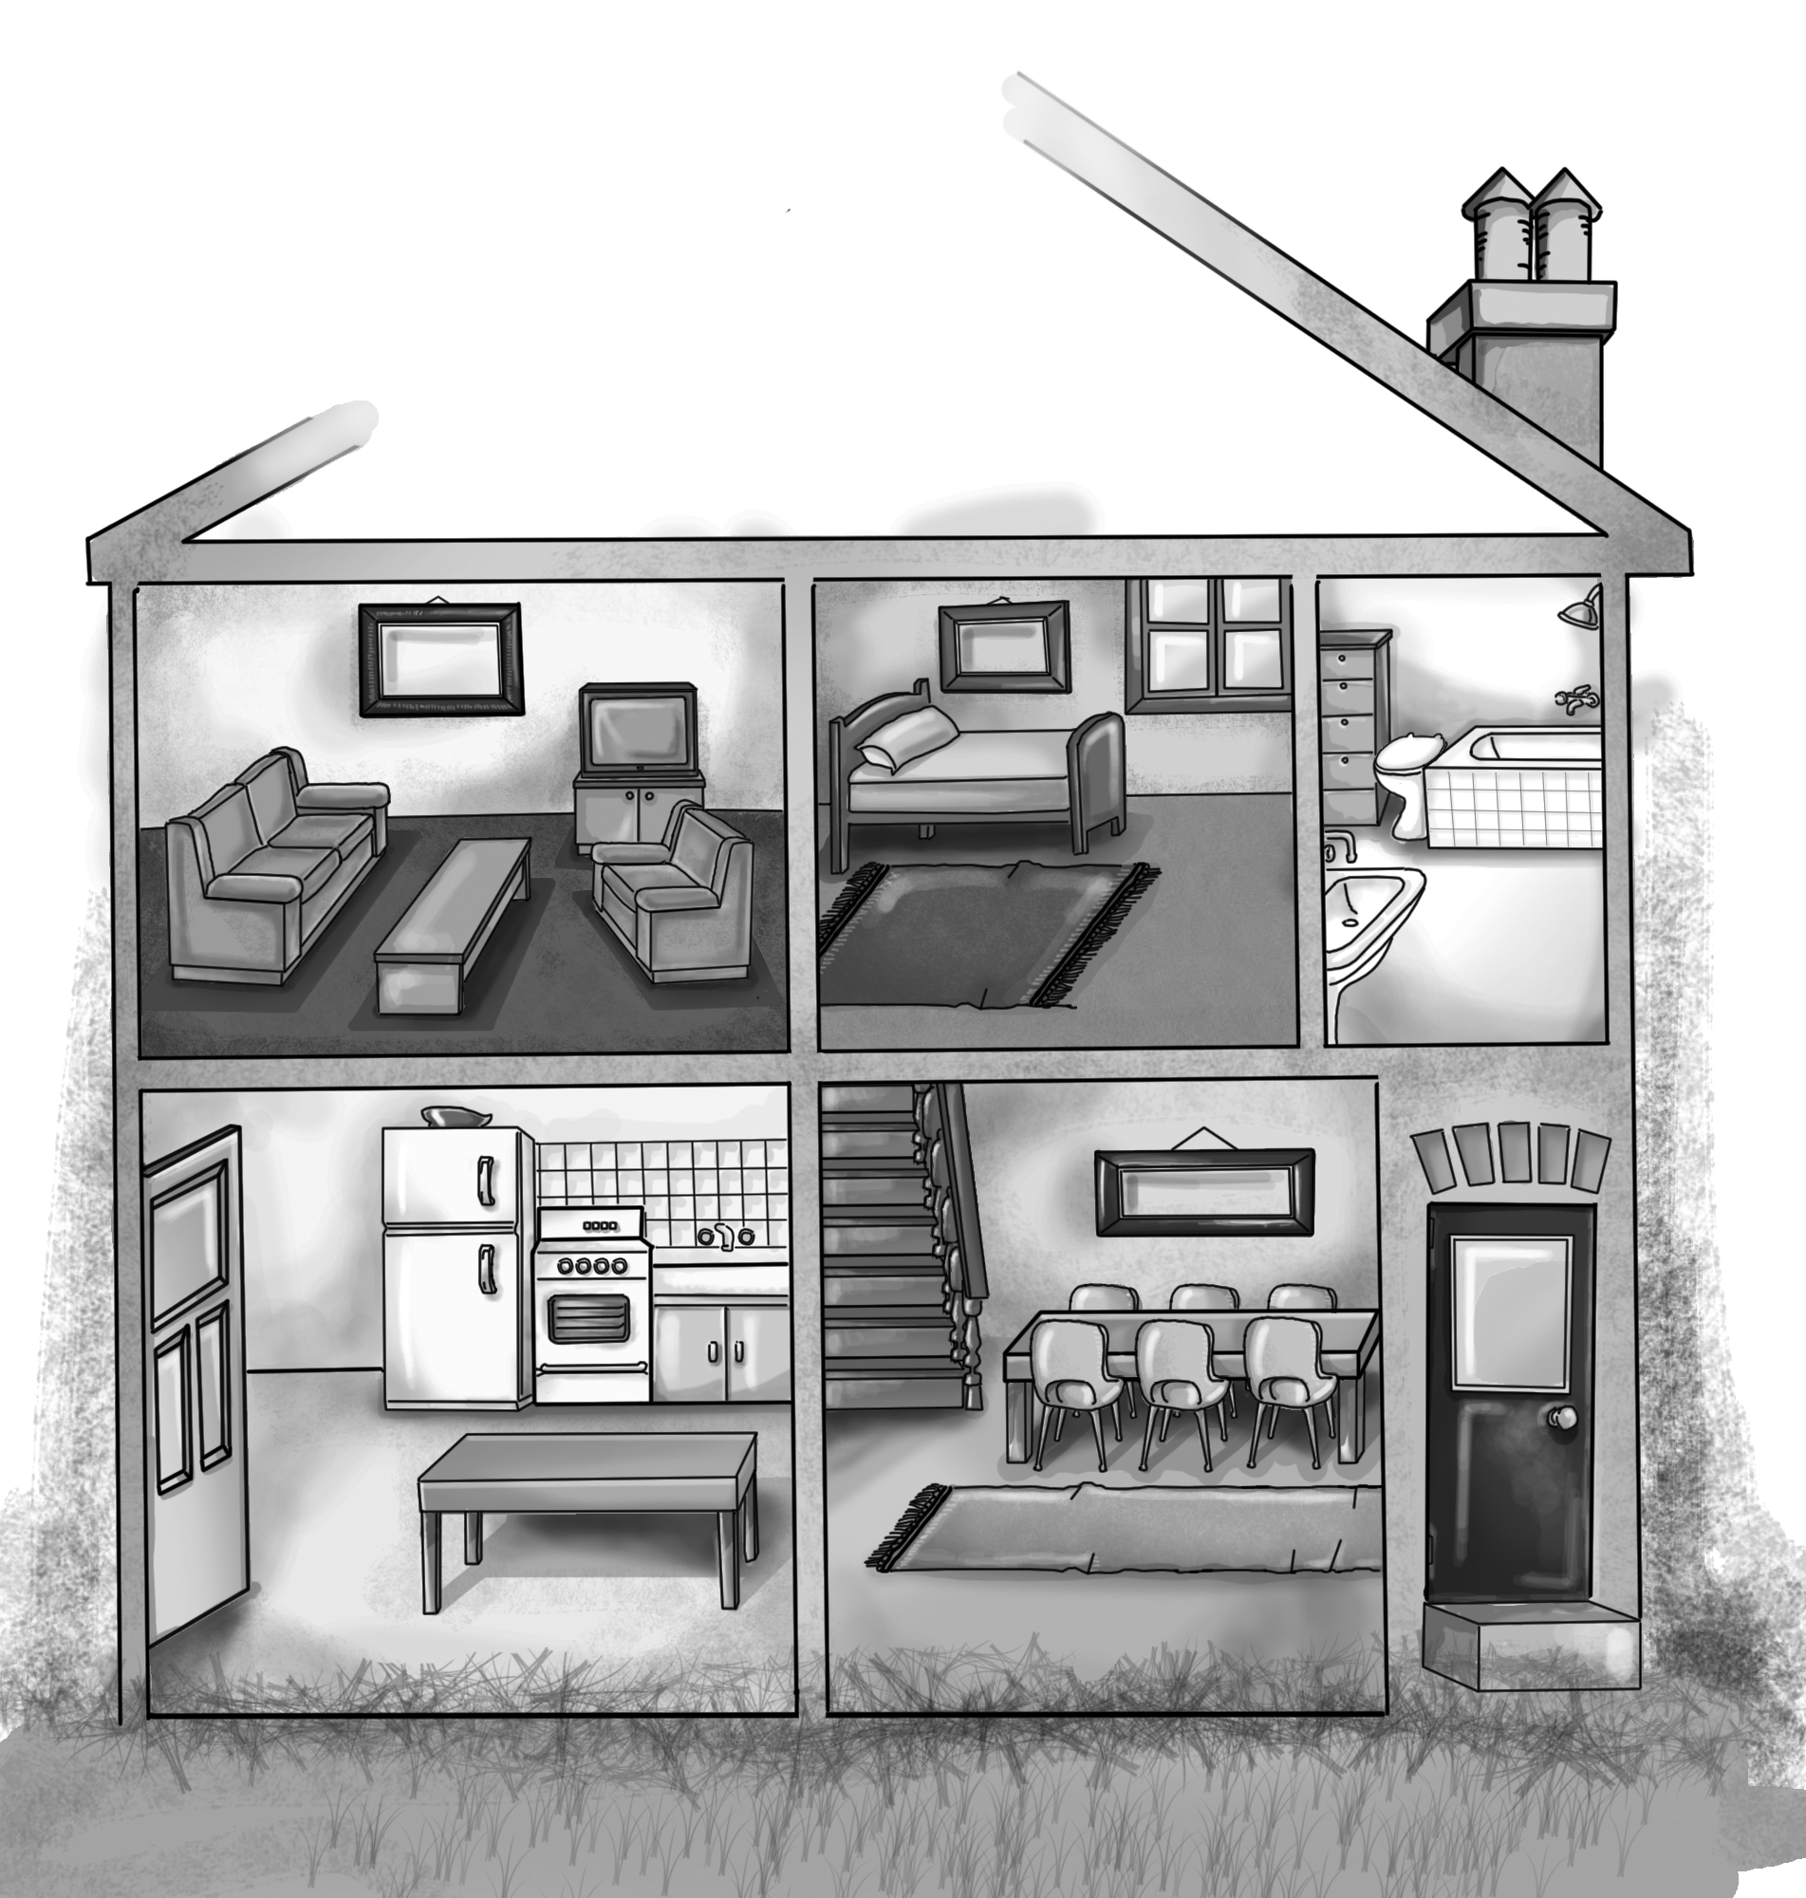





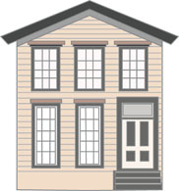

1- There was a big house and in it, there were two floors.

2- There are rooms in the big house .

3- There is a living room next to a bedroom.

4- There is a table between armchair and sofa .



Kingdom of Saudi Arabia

Ministry of Education

Om Al Moamnean Elementary School

The 4th period Exam for the 6th Grade

Student's Name:

…………………………………………………

|  |  |  |  |  |  |
| --- | --- | --- | --- | --- | --- |
| 80% | 90%-80% | 100%-90% | 100% | Recognise and produce long vowels: /ju:/ as in "huge" and as in "barbecue", as in "purse" and as in bird | المعيار 7 |
|  |  |  |  |

1- Listen then unscramble the words :









tuec eulg uqmose deTsuya

…………………… …………………… ………………….. ……………………...

|  |  |  |  |  |  |
| --- | --- | --- | --- | --- | --- |
| 80% | 90%-80% | 100%-90% | 100% | Give directions | المعيار 24 |
|  |  |  |  |

2- Write the names of the following directions correctly :



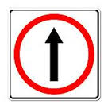



………………………. ……………………… ……………………..

|  |  |  |  |  |  |
| --- | --- | --- | --- | --- | --- |
| 80% | 90%-80% | 100%-90% | 100% | Talk about rules using the imperative | المعيار 25 |
|  |  |  |  |

3- Write the names of the following signs correctly :

Keep of grass - Switch of cell phones - No Talking - No eating or drinking - No skateboard - No Balls

|  |  |  |  |
| --- | --- | --- | --- |
| …………………….. | C:\Users\SUN 28-08\Desktop\مجلد جديد ‫‬\no-grass-sign-black-and-white-176984213.jpg | …………………….. | C:\Users\SUN 28-08\Desktop\مجلد جديد ‫‬\no ball.jpg |
| …………………….. | C:\Users\SUN 28-08\Desktop\مجلد جديد ‫‬\no-talking-or-chat-is-allowed-149409824.jpg | …………………….. | C:\Users\SUN 28-08\Desktop\مجلد جديد ‫‬\no_cell_phones_allowed_clip_art_16863.jpg |
| …………………….. | C:\Users\SUN 28-08\Desktop\مجلد جديد ‫‬\no eat.gif | …………………….. | C:\Users\SUN 28-08\Desktop\مجلد جديد ‫‬\No-skateboarding-sign-Stock-Vector.jpg |