We can 5 – Unit 3 – Sports and Activities - 6th year

Name/

Comparing

Comparatives and Superlatives (long adjectives)

**1-Choose and write the correct words under the pictures:**

**tennis- football- horse riding- volleyball- basketball**

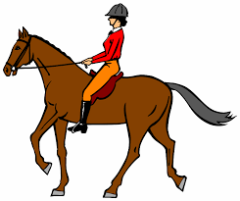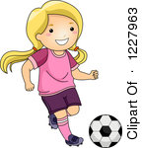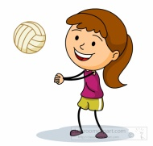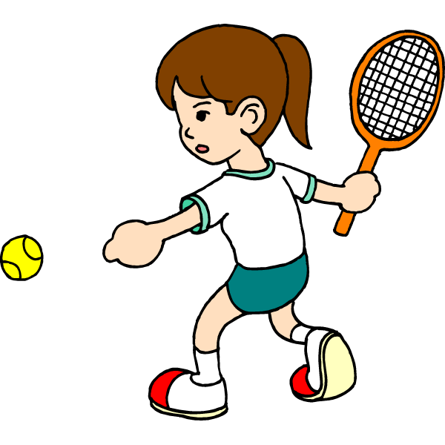

**Scopa diving - sky diving - hang gliding- bungee jumping - rock climbing**

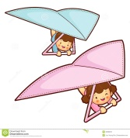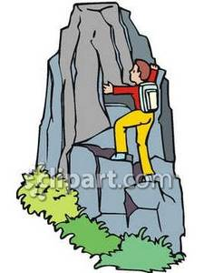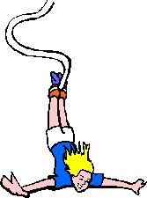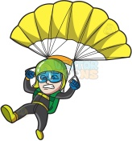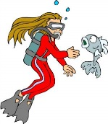

**Pottery - computer games - running - word games - drawing**

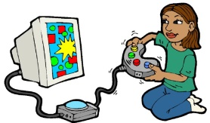

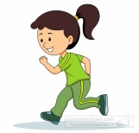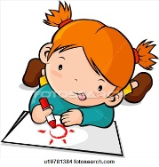

**2-Choose the correct answer:**

* Horse riding is (more – the most ) exciting than cycling.
* Rock climbing is (more – the most ) dangerous than jogging.
* Roller skating is ( more – the most ) exciting than running.
* Hang gliding is ( more - the most dangerous.
* What’s (more - the most) exciting for you?
* What’s (more - the most) boring for you?
* What’s (more - the most) difficult for you?