We can 5 – Unit 2 – Sea Animals- 6th year

Name/

Comparing

Comparatives and Superlatives

**1-Choose and write the correct words under the pictures:**

**Baby seal- whale- dolphin- sea animals- sea horses**

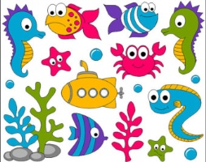

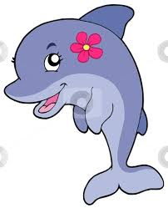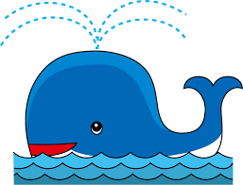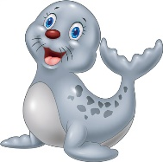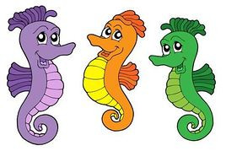

**crab- octopus- starfish- walrus- shark**

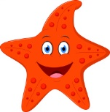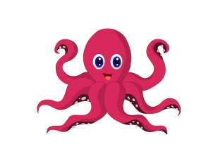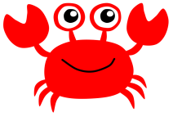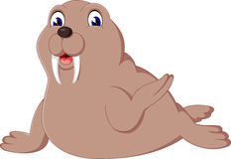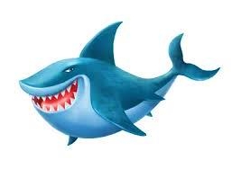

**eel- turtle- seagull- jellyfish- squid**

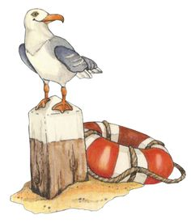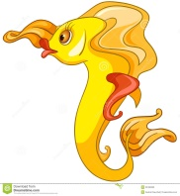

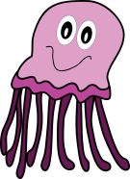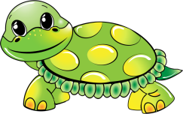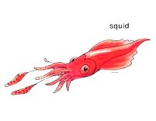

**2-Choose the correct answer:**

* I think whales are ( big – bigger – the biggest) than sharks.
* I think crabs are ( fast – faster – the fastest ) than turtles.
* I think a baby seal is ( cute – cuter – the cutest ) than dolphins.
* I think turtles are ( slow – slower – the slowest ) than the walrus.
* I think a squid is ( small – smaller- the smallest ) than whales.
* I think whales are ( big- bigger – the biggest ) animal in the sea.
* I think the turtle is ( slow- slower – the slowest ).
* I think a shark is ( scary – scarier – the scariest ) animal in the sea.
* I think sharks are as ( scary - scarier – the scariest ) as eels.
* I think turtles as ( cute – cuter – the cutest ) as dolphins.