

Kingdome of Saudi Arabia ministry of Education school al-Rona elementary

**الاسم : .........................................**

**الصف ِ....................**

**اختبار مادة English الصف خامس الفترة الثانية الفصل الدراسي الأول 1437-1438 هـ**

|  |  |  |  |
| --- | --- | --- | --- |
| **الرقم** | **المعيار** | **الدرجة** | **المستوى** |
| 11 | Identify and talk about people using verb to be . |  |  |

1 ) Complete :

|  |  |  |  |
| --- | --- | --- | --- |
| **الرقم** | **المعيار** | **الدرجة** | **المستوى** |
| 23 | Talk about food using want and describe different kinds of food and drink using adjectives . |  |  |

2 )Choose :

 1- Apple is ( sweet – sour ) .

2- Chips are ( **salty – sour** ) .

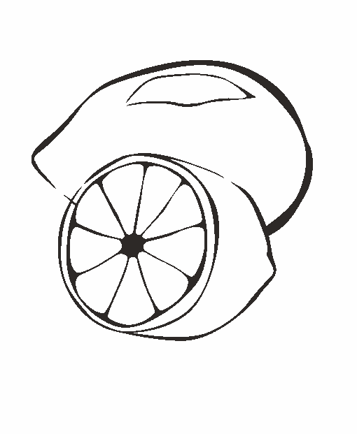3-Rice is( hot – cold ) .

4-Lemons are ( sour – hot ) .

|  |  |  |  |
| --- | --- | --- | --- |
| **الرقم** | **المعيار** | **الدرجة** | **المستوى** |
| 29 | Identify and talk about at different times of the day :Good morning, evening , afternoon, night |  |  |

3 ) Write :

|  |  |  |  |
| --- | --- | --- | --- |
| Good afternoon | Good night | Good morning | Good evening |

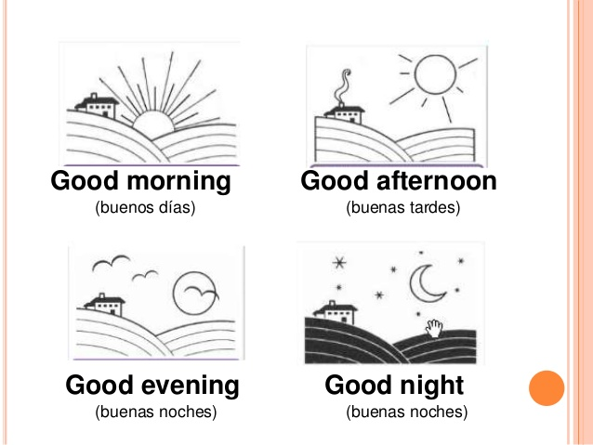

**…………………………………………..**  **………………………………………………..**

**…………………………………………….. ………………………………………………….**

|  |  |  |  |
| --- | --- | --- | --- |
| **الرقم** | **المعيار** | **الدرجة** | **المستوى** |
| 42 | Write short simple sentence to convey basic personal information |  |  |

4 ) Write about yourself :

|  |  |  |  |  |  |  |
| --- | --- | --- | --- | --- | --- | --- |
| uniform | sister | brother | mom | dad | age | name |

Personal Information

My name is ……………………………………  **.** I am ………………  **.** I have ………………… and ……………………  **.** I have ……… brother and ……… sister **.**

I wear uniform …………………………… and …………………………  **.**

|  |  |  |  |
| --- | --- | --- | --- |
| **الرقم** | **المعيار** | **الدرجة** | **المستوى** |
| 45 | Use the definite and indefinite articles( a – an – the ) |  |  |

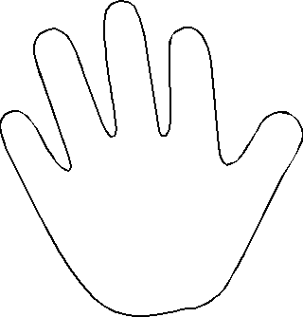5 ) A - Draw the diagram :

B - Put (a – an) :

1- this is………… apple .

2- this is ……….. pen .

3- that is ………. book .

4- that is ………. orange .

an

|  |  |  |  |
| --- | --- | --- | --- |
| **الرقم** | **المعيار** | **الدرجة** | **المستوى** |
| 42 | Ask about activity happening of speaking using present progressive |  |  |

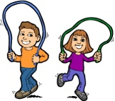6 ) Choose :

1- We are ( playing – play ) .

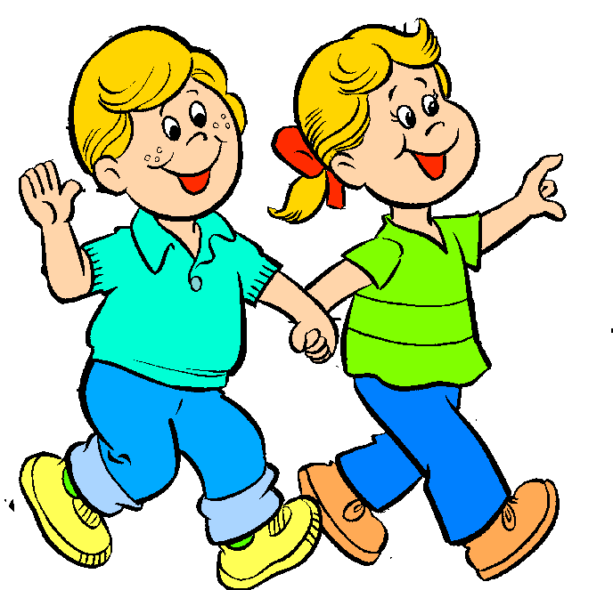2- He ( is – are ) laughing .

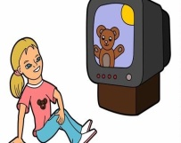3 - They are ( walking – talking )

4- Is she watching TV ? **( Y**es – No ) she is .

Good Luck

T / Khayriah Saeed