

Subject………………………… المادة

Date…………………………….. التاريخ

Period…………………………. الفترة

Class…………………………….. الصف

Kingdom of Saudi Arabia

General Administration for Girls at Asseer

The Elementary ……………………

The 4th period of 4th Grade for English Exam 2nd Term 1436-1437 H

**الاسم / .............................................. الصف / ...................................**

|  |  |  |  |
| --- | --- | --- | --- |
| المستوى | الدرجة | المعيار | الرقم |
|  |  | Recognize and different between some English letters (b,p- f,v- ch,sh) . | 34 |

1. **Circle the correct sound :**

|  |  |  |  |  |  |
| --- | --- | --- | --- | --- | --- |
| **https://upload.wikimedia.org/wikipedia/commons/e/e1/03-BICcristal2008-03-26.jpgb-p** | **http://static.kodajo.com/images/user/fileUp/7a658e687aa0cb3f805ffd19c07e64db.jpgp-b** | **http://cdn.grid.fotosearch.com/CSP/CSP691/k6919247.jpgf-v** | **http://classroomclipart.com/images/gallery/Clipart/Animals/Fox_Clipart/TN_red-fox-clipart-581212.jpgv-f** | **http://images.clipartpanda.com/ship-clipart-6Tr6KMd8c.pngCh-sh** | **http://static.tumblr.com/0ee21b1cf4ad4b2057305b00cb5f9669/ihh9sai/uUWmr68oc/tumblr_static_tumblr_static_cheese_205_1362800142.jpgSh-ch** |
|  |  |  |  |  |  |

|  |  |  |  |
| --- | --- | --- | --- |
| المستوى | الدرجة | المعيار | الرقم |
|  |  | Identify and talk about animals . | 18 |

1. **Match** :

|  |  |  |  |  |  |  |  |
| --- | --- | --- | --- | --- | --- | --- | --- |
| Sunday | Cow | Monday | Fish | Tuesday | Cat | Wednesday | Sheep |

|  |  |  |  |
| --- | --- | --- | --- |
| المستوى | الدرجة | المعيار | الرقم |
|  |  | Read and count numbers (10-100) . |  |

1. **Count :**



……..

|  |  |  |  |
| --- | --- | --- | --- |
| المستوى | الدرجة | المعيار | الرقم |
|  |  | Do controlled writing such as supplying missing letters and words . | 34 |

1. 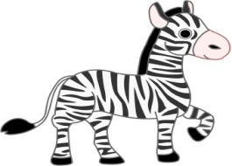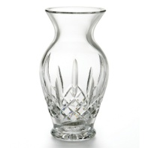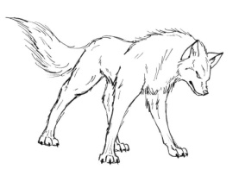**Choose the correct letters :**

**Z**

**U**

**V**

**W**

**………olf ………ase ……mbrella ………ebra**

|  |  |  |  |
| --- | --- | --- | --- |
| المستوى | الدرجة | المعيار | الرقم |
|  |  | Handwriting Instructions | 29-30-31-32-33-35 |

1. **Copy :**

|  |
| --- |
| -------------------------------------------------------------------------------------------------------------------------------------------------------------------------------------------------------------------- |

|  |
| --- |
| ------------------------------------------------------------------------------------------------------------------------------------------------------------------------------------------------------------------ |

|  |  |  |  |
| --- | --- | --- | --- |
| المستوى | الدرجة | المعيار | الرقم |
|  |  | Recognize short and long vowels : | **2** |

1. **Circle the sound :**

Tap tape

( ) ( )

Top rope

( ) ( )

|  |  |  |  |
| --- | --- | --- | --- |
| المستوى | الدرجة | المعيار | الرقم |
|  |  | Write guided short answers to written questions . |  |

1. 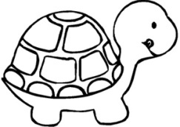Answer :

A ) Do you have a pet ? ………………………………………………

B ) What the weather like today ? It is ……………………

Good Luck

Khayriah Saeed