- Listen and recognise some consonant sounds, endings of third person singular and long vowels.
(1) | (2) | (3) | (4)
 |  |  | 
ele _ _ ant | read _ | tou _ _ | b _ _
(5) | (6) | (7) | (8)
 |  |  | 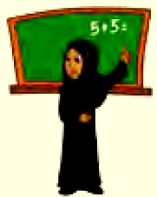
walk _ | p _ _ | r _ _ n | teach _ _

- Do as shown:
- Use: (hasn't got - have got )
- I __________________ brown eyes.
- He __________________ brown eyes.
- Use: (is - can - ’m)
- My name’s Salim. I________ 12 years old. My favourite sport ________ football. I ________ play football very well.
- Answer with: (No)
- Can you play basketball?
______________________________________.
- Answer with: (Yes)
- Is he your father?
______________________________________.

- Match activities, occupations, sports and household chores to the correct sentences.
- He is doing gymnastics. |  | 
- He is a firefighter. |  | 
- He gets dressed.
- She is making a cake. |  | 
- They walk to school every morning. |  | 
- He is a chef. |  | 

- Use prepositions of time (in, on. before, at, after).
I always have a shower ________ the morning. I always do my homework ________ school. I never watch TV ________ bedtime. I sometimes go to bed ________ 11:00 ________ Thursdays.
- Answer: write simple sentences to convey personal information.
- What do you want to be when you grow up?
___________________________________________________.
- Why?
___________________________________________________.

- Punctuate.
salim isn t skateboarding. he s playing volleyball
