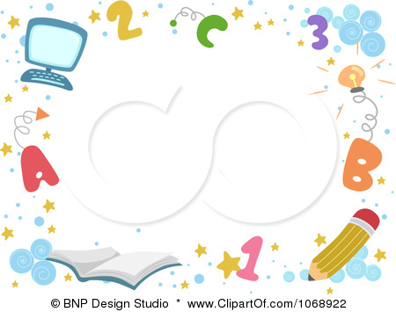
Distribution of the Syllabus For
fourth Grade second Term 1437 – 1438

6th week | 5th week | 4th week | 3rd week | 2nd week | 1st week
13-6/17-6 | 6-6/10-6 | 29-5/3-6 | 22 –5 26/5 | 15-5/19-5 | 8-5/12-5
Unit 3  Talk time  Rhythms &sounds | Unit 2  Phonics  evaluation | Unit 2  Rhythms &sounds  Words | evaluation  Unit 2  Talk time | Unit 1  Words  Phonics | Unit 1  Talk time  Rhythms &sounds
12th week | 11th week | 10th week | 9th week | 8th week | 7th week
4 / 8 – 8/ 8 | 26 / 7 – 1/ 8 | 19/ 7 – 23/ 7 | 12/ 7 – 16 / 7 | 27 /6-2/7 | 20-6/24-6
Unit 5  Words  Phonics | Unit 5  Talk time  Rhythms &sounds | Unit 4  Phonics  evaluation | Unit 4  Rhythms &sounds  Words | evaluation  Unit 4  Talk time | Unit 3  Words  Phonics
18th week | 17th week | 16th week | 15th week | 14th week | 13th week
16/ 9 –20/ 9 | 9/ 9 – 13 /9 | 2 /9 –6/ 9 | 25 / 8 – 29 /8 | 18 / 8 – 22 / 8 | 11 / 8 –15/ 8
The Final  Exams | The Final  Exams | Revisions | Phonic Practice | Work Sheet | evaluation
مدير/ ة المدرسة :أ.

مشرف/ة المادة : أ

معلم /ة المادة

التوقيع :

التوقيع :

التوقيع :

