The 4th period Exam for the 5th Grade
Student's Name:
…………………………………………………

Kingdom of Saudi Arabia
Ministry of Education
Om Al Moamnean Elementary School

80% | 90%-80% | 100%-90% | 100% | Ask questions using What, Who, Where  Ask about and tell the time (o’clock only  Ask and respond to simple sentences about everyday activities in the Present Simple tense using the first and second person singular.. | المعيار 7 – 25 - 27
1- Answer the following :

1- What time do you get up ?
…………………………………………………………………..

2- Do you watch TV in the evening ?
…………………………………………………………………..

3- Where do you eat lunch ?
……………………………………………………………………
4- What does your dad do ?
………………………………………………………………..
2- Listen then match :


1- I get up at six o'clock.
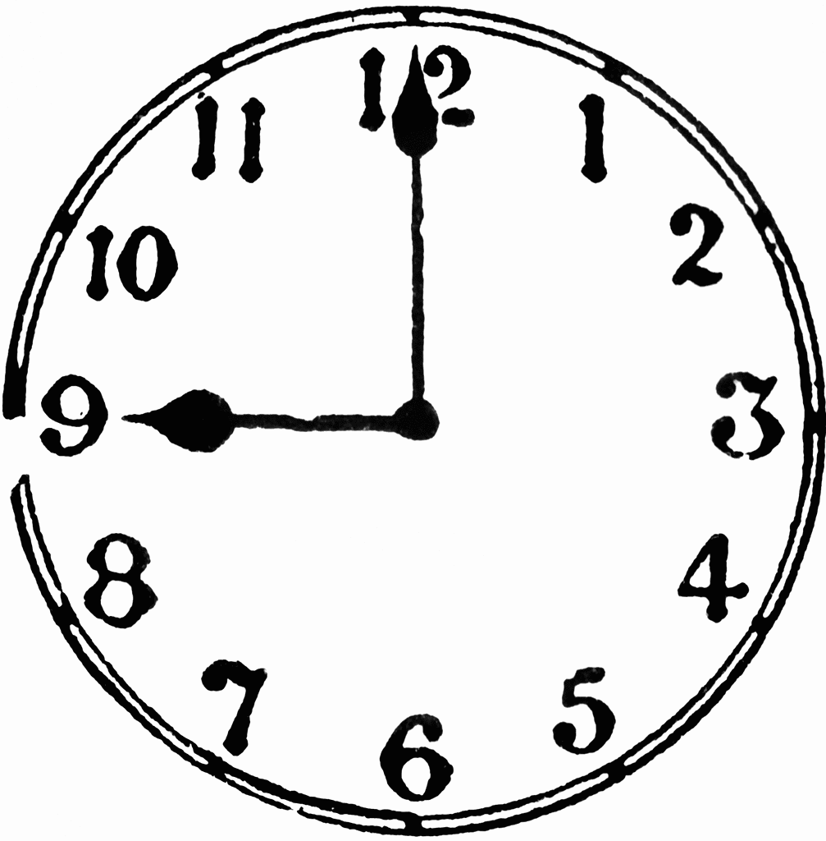


2- I eat lunch at two o'clock .
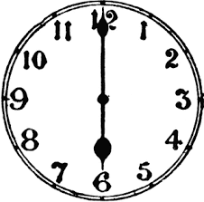
do my homework at five o'clock. 3- I


4- I go to bed at nine o'clock.
80% | 90%-80% | 100%-90% | 100% | Identify and Talk about days of the week , months & seasons . | المعيار 26
1- Rearrange the days of the week correctly :
Monday - Friday - Wednesday - Saturday - Thursday - Sunday - Tuesday



2- Match the following correctly :

1- It's sunny and hot in summer.

2- It's snowy and cold in winter.


3- It's not cold in spring.


4- It's windy in autumn.
Kingdom of Saudi Arabia
Ministry of Education
Om Al Moamnean Elementary School
The 4th period Exam for the 5th Grade
Student's Name:
…………………………………………………

80% | 90%-80% | 100%-90% | 100% | Describe animals using possessive adjectives (its, their).  Talk about ability (can/can’t). | المعيار 17- 18
1- Match :

1- Its jaws are big.
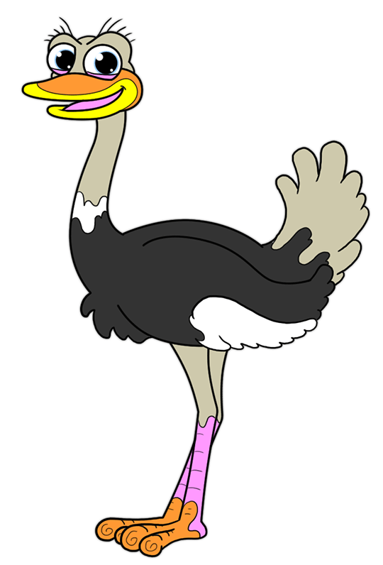
2- Their eyes are pop out.

3- It can bite.

4- They can't fly.


2- Answer the following questions :

1- Can elephants swim ?
………………………………………………………………….
2- Can snake run ?
………………………………………………………………..
Kingdom of Saudi Arabia
Ministry of Education
Om Al Moamnean Elementary School
The 4th period Exam for the 5th Grade
Student's Name:
…………………………………………………

80% | 90%-80% | 100%-90% | 100% | Talk about the weather | المعيار 21
1- Write the words under the pictures correctly :
Cloudy - Sunny - Rainy - Windy - Snowy

It's………………………………….

It's………………………….

It's………………………………….

Weather

It's………………………………….


It's………………………………….

80% | 90%-80% | 100%-90% | 100% | Identify occupations and talk about what someone does using the Present Simple (Affirmative, Negative, Interrogative and short answers). | المعيار 32
: 1- Write the names of the following jobs correctly
Doctor – cook – farmer – businessman – pilot – firefighter





Jobs

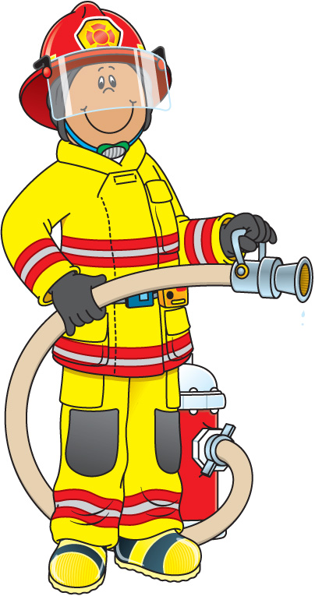

2- Match the following :


1- He's a farmer.


2- She's a teacher.

3- He's a pilot.

4- She's a doctor.
Kingdom of Saudi Arabia
Ministry of Education
Om Al Moamnean Elementary School
The 4th period Exam for the 5th Grade
Student's Name:
…………………………………………………

80% | 90%-80% | 100%-90% | 100% | Identify occupations and talk about what someone does using the Present Simple (Affirmative, Negative, Interrogative and short answers). | المعيار 32
1- Choose the correct answer :
1- a- What does he do ? b- Is she a farmer ?

He's a teacher .
2- Does he work in a hospital ?
a- No, he doesn't. b- Yes, she's a teacher.
2- Write the answers :
1- Is he a computer technician ?
…………………………………………...
2- Is she a teacher ?
……………………………………………
80% | 90%-80% | 100%-90% | 100% | Link ideas with commas and and  Link ideas with but | المعيار 47- 48
1- Choose the correct conjunctions :

1- She has long { , / . } brown hair
{ and / but } brown eyes .


2- It can swim { but / and } it can't speak .
80% | 90%-80% | 100%-90% | 100% | Describe physical appearance | المعيار 15
1- Listen then match :

1- She has long, yellow hair . She's wearing
a long dress .

2- He has short, black hair and wearing a thobe.

3- She has short, black hair and wearing a hat.

80% | 90%-80% | 100%-90% | 100% | Identify and talk about places in a town and their location using there is, there are and next to, opposite, between.  Identify and talk about rooms/items in a house | المعيار 20 -13
1- Match the following correctly :
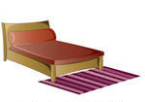
1- There is a table between the sofa
and the armchair.
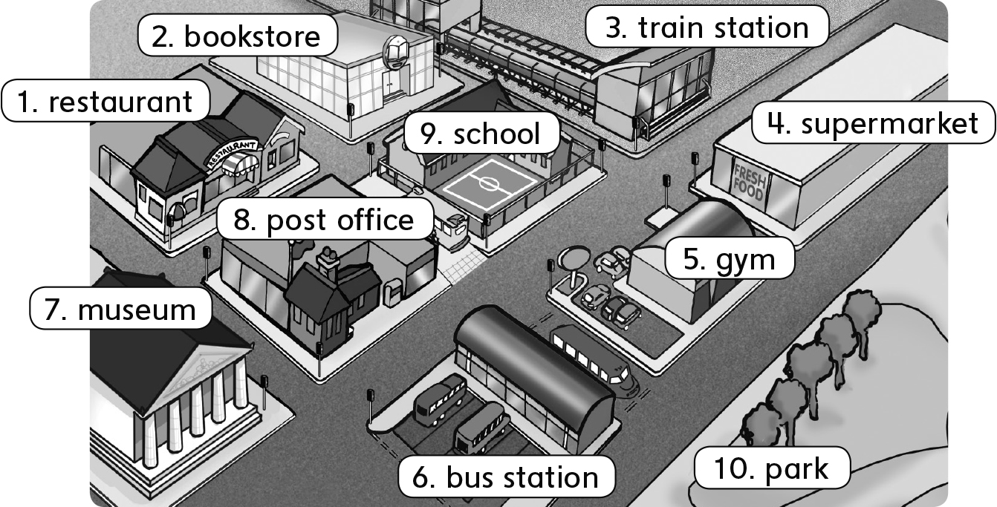

2- There's a rug in front of the bed.
3- There's a supermarket opposite the gym.

4- There's a museum near the restaurant.
80% | 90%-80% | 100%-90% | 100% | Identify irregular plural noun | المعيار 8

1- Match the following :

1- This is a foot.

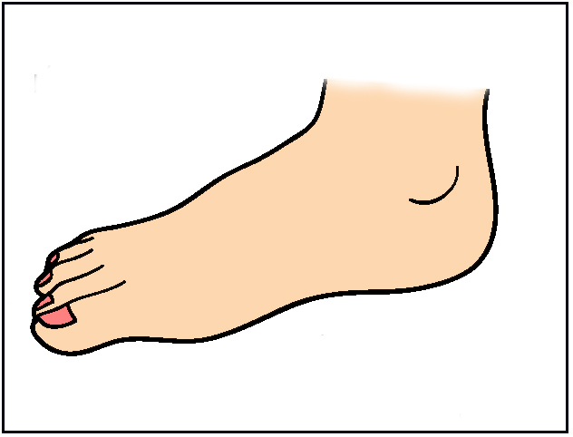
2- These are teeth.
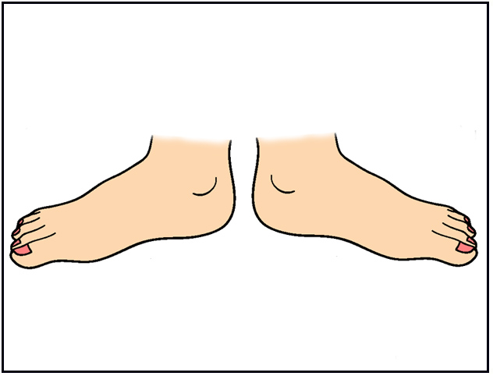
3- That is a mouse.

4- Those are feet.
2- Write the plural forms of the following :
 |  | Plural |  |  |  |  | Singular
 |  | ………………… |  |  |  |  |  man
 |  | ……..……………  |  |  |  |  | woman
 |  | …………………  |  |  |  |  | child
 | 80% |  | 90%-80% | 100%-90% | 100% | Recognize short and long vowels: (a, /??/ as in “dates”, i, /??/ as in “rice”, o, /??/ as in “rose”, ea, /??/ as in “teacher”, ea, /?/ as in “bread”, oo, /??/ as in “food”, oo, /?/ as in “book”, u, /j??/ as in “computer”, u, /?/ as in “duck |  | المعيار 1
1- Listen then write correctly :
ee
ea


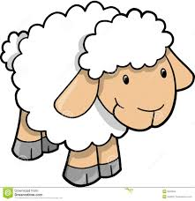
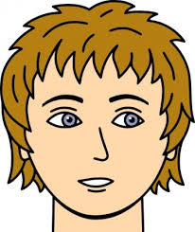

H _ _ d sh _ _ p m _ _ t br _ _ d
2- Circle the word you'll hear :
1- Read - Red
2- Head - meat
3- Sheep - Ship
80% | 90%-80% | 100%-90% | 100% | Use the intensifier very | المعيار 9
3- Match the following :
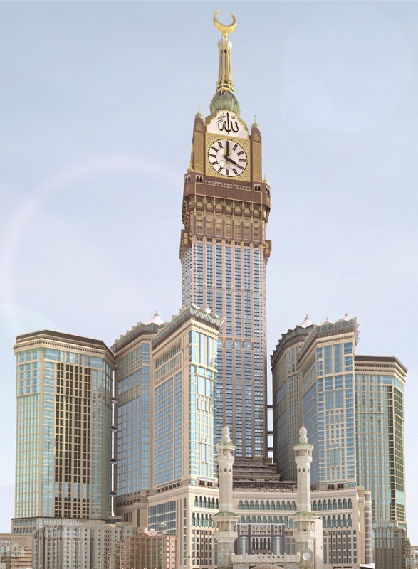
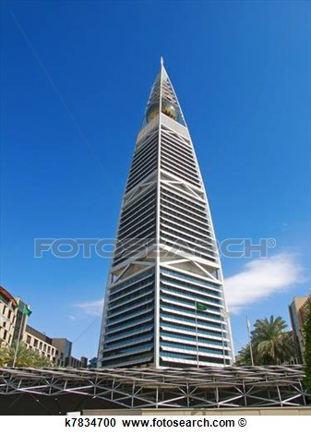

1- Faisaliah Tower is in Riyadh. It's very tall.
2- Clock Tower is in Makkah. It's very beautiful.

