General Summary on U3 THINGS WE DO

1- Choose correctly :
1- What are you doing ?
a- I'm cooking. b- She' playing football.
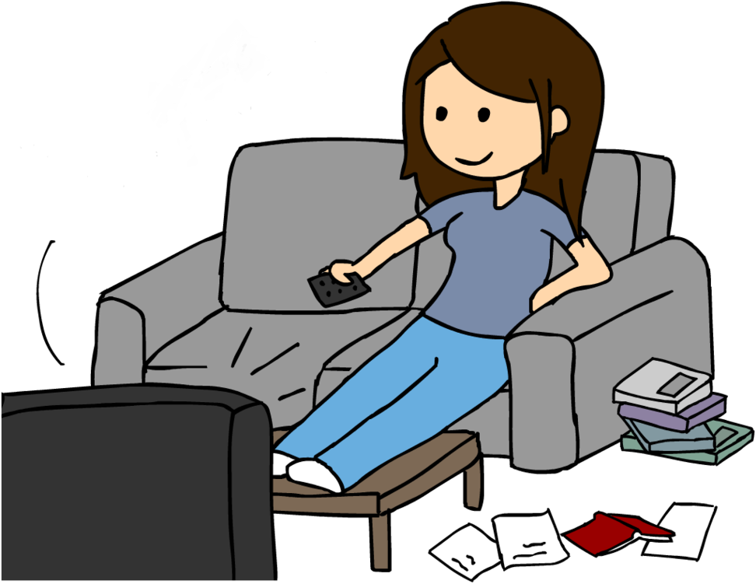
2- She's watching TV .
a- What's your name ?
b- What's your mom doing ?

2- Listen then write the vowel letters correctly :
{ a / i / o / e / u }

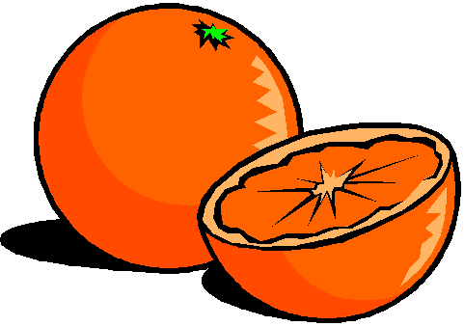

_ ce cream _ lephant _ range

_ pple _ mbrella

3- Read then Match :
Phone - Photo - Phonics - Elephant
 |  | 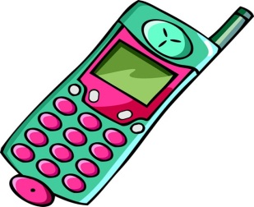 | 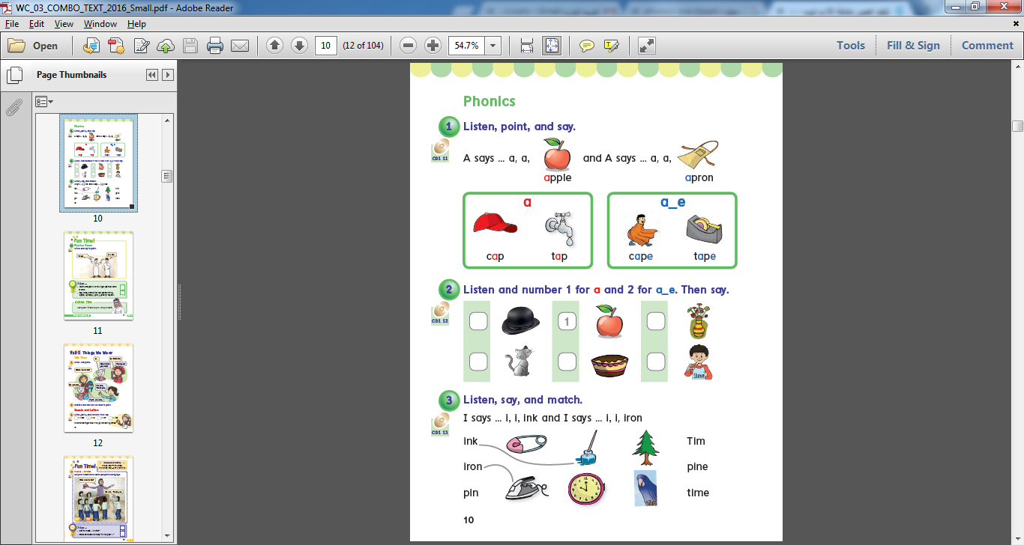

4- Write the correct punctuations :
{ , / . / ? / I }

What're you doing

'm playing karate playing karate
And how about you ?

5- Listen then Circle :
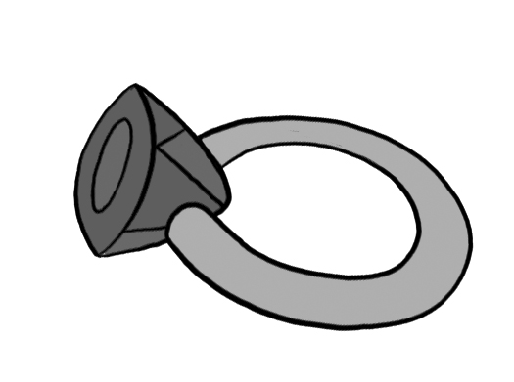
ring rink
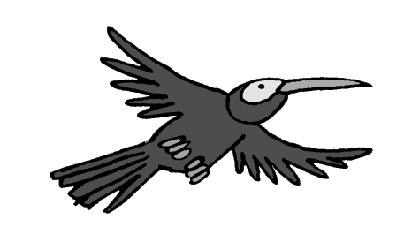
wink wing

peaking speaking

6- Listen then circle the correct answer :

He's playing computer games games.
I'm doing Karate.

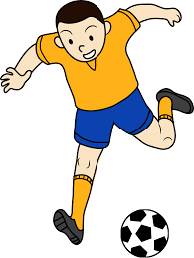
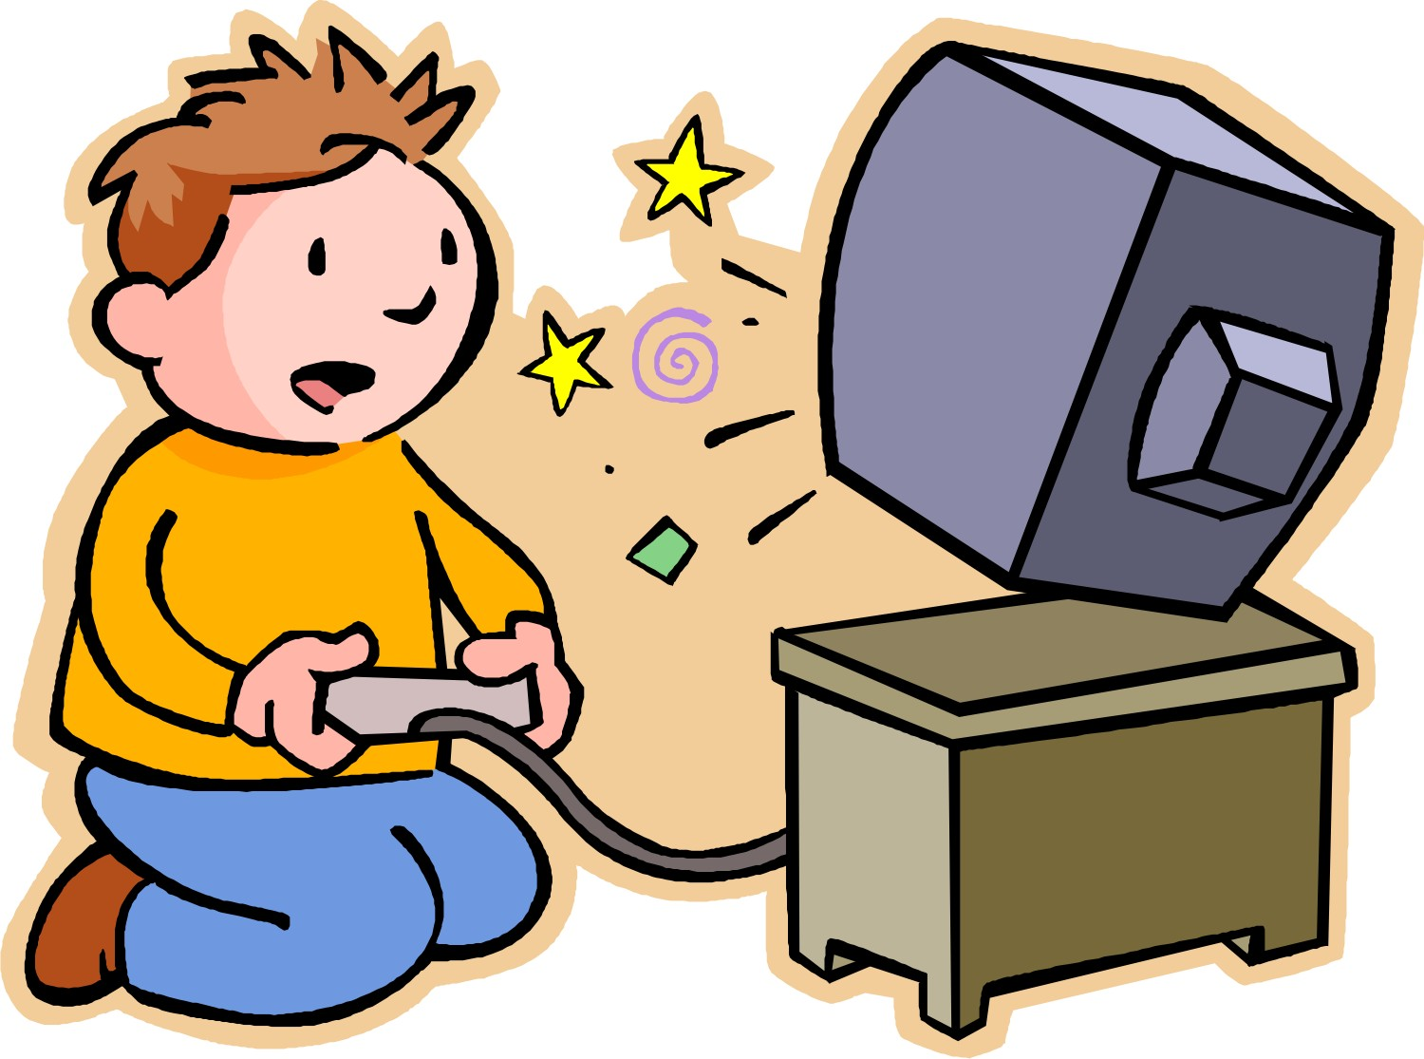

X √
X √

They're watching TV.
She's doing homework.



X √
X √

He's playing football.
I'm eating a snack.

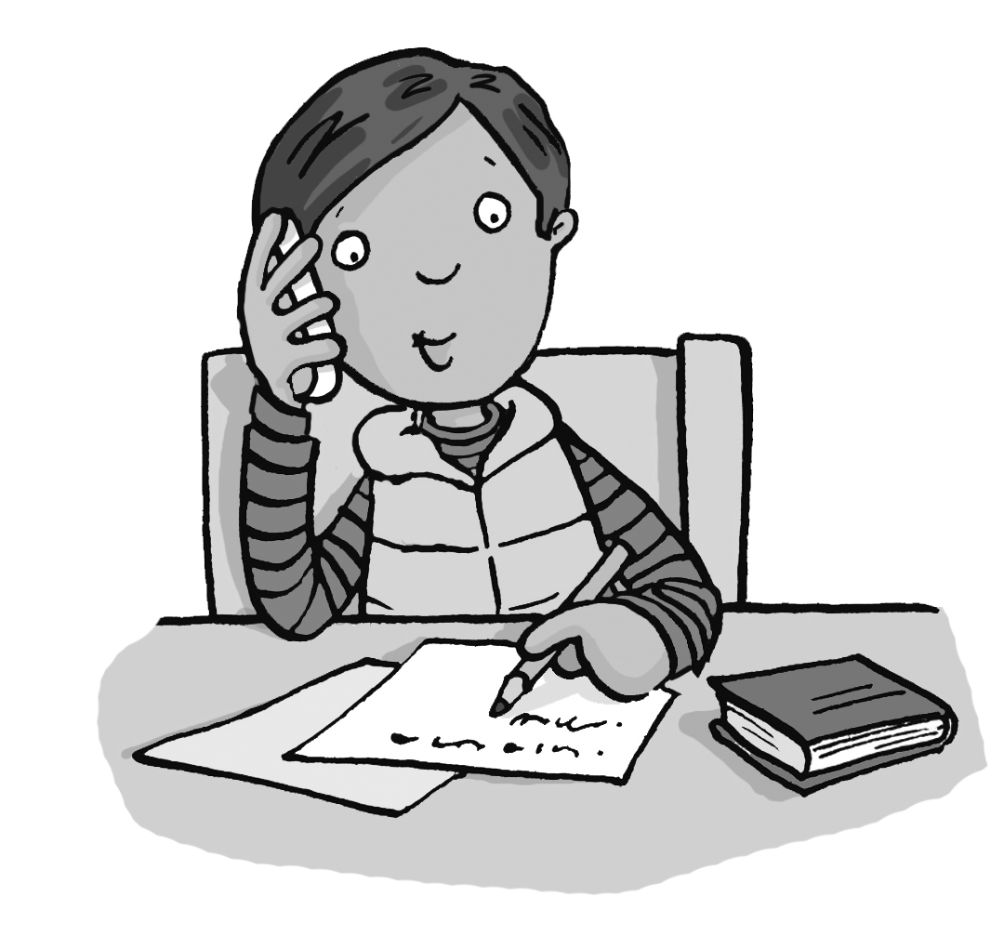


X √
X √

7- Listen then Write :
Tr / Dr





_ _ee _ _ uck _ _ess _ _ink

8- Listen then circle correctly :
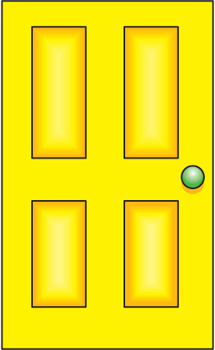


d t / d t / d t / d t /

9- Read then Match :
1- It's tall . 3- It's short .
2- It's fat . 4- It's small .



