General Summary for U3 MY FAMILY
1- Listen then Match :

1- This is my sister Huda.
2- Nice to meet you.
3- Nice to meet you, too.

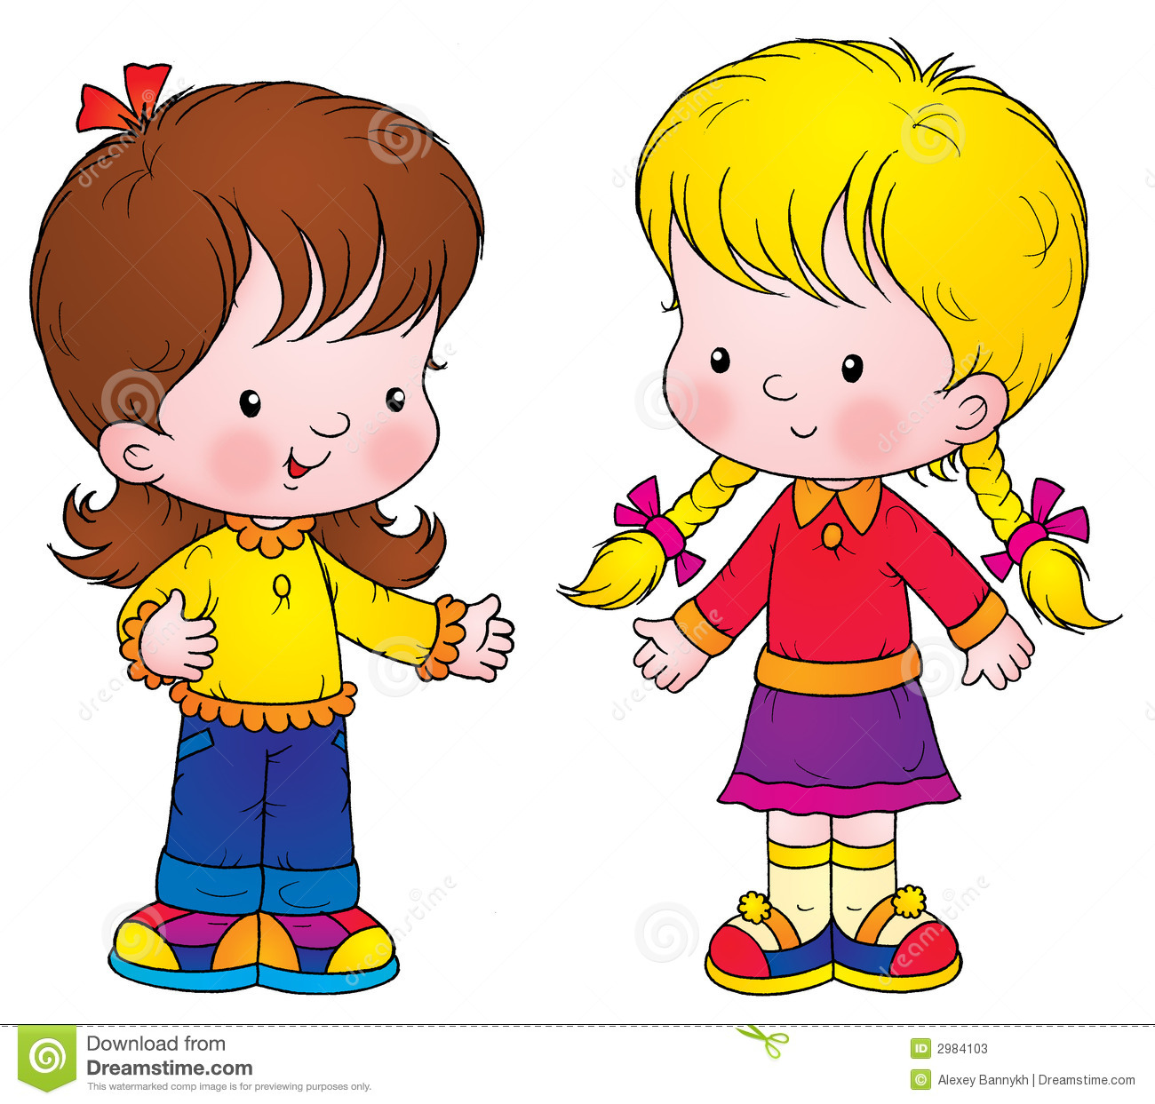


2- Listen, Read then Write correctly :

Sister - Mom - Brother - Dad - Grandma - Grandpa - Baby


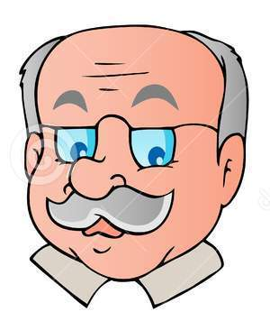

3- Listen , choose then write the correct letter :

B / E / D

A / C / D

B / C / D
_ ear

_ ow

_ uck

A / C / F

A / B / E

_ gg

_ pple

4- Rearrange the letters correctly :

D A C E B

5- Write the small letters correctly :

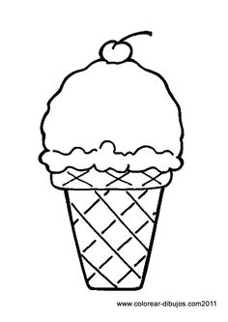

A
B
C

E
D

